**KF6017 - Software Architecture for Games**

**W16015479**

**Class Diagram**

The diagram below shows a full class diagram of my Game Engine. It shows the full structure of the game engine I have created, showing the complete hierarchy display relationships and associations.

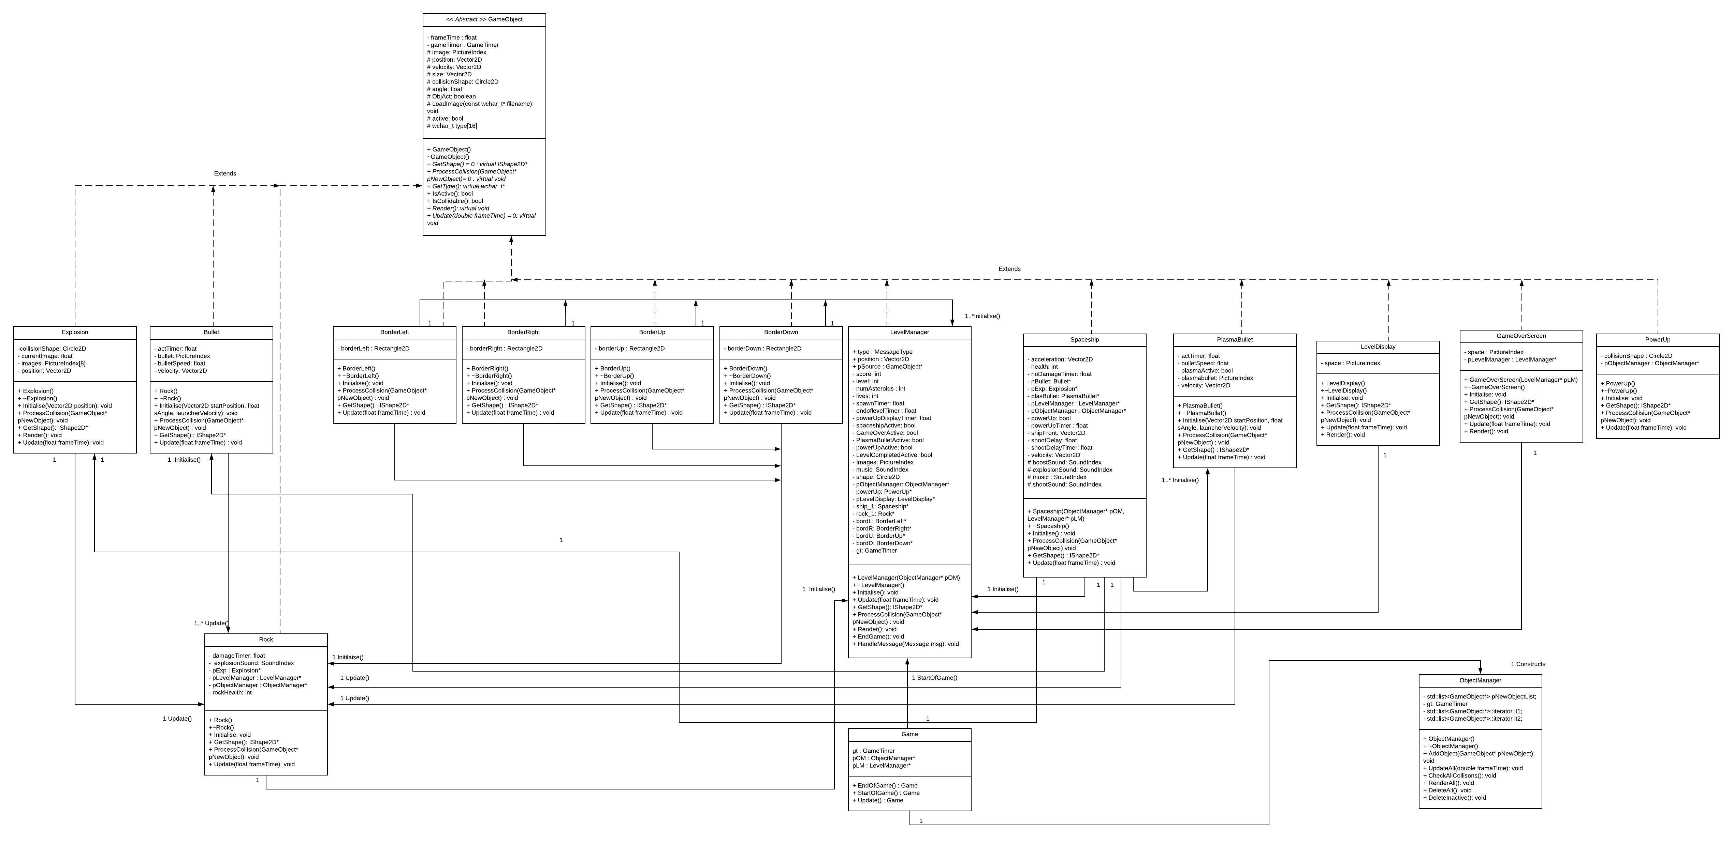

**Dynamic Model**

The diagram below shows how an object manager checks for collision between a game object and how the object will respond to the detected collision. In this case a spaceship object will be colliding with an asteroid which in turn will destroy and delete the spaceship object from the level. As shown in the diagram the player will control the spaceship in the level until it intersects with the asteroid and in doing so activates the process collision function which will trigger an explosion image and delete the inactive object then using the object manager class it will remove the object from the engine.

